Assignment 2 writeup

a2map.py

The confusion matrix and graph are shown as bellow. The correctness rate is 71.5%.

|  |  |  |
| --- | --- | --- |
| Truth\Predict | 0 | 1 |
| 0 | 64 | 36 |
| 1 | 21 | 79 |

Comparison between linear square classifier, k nearest neighbor classifier and Bayes classifier:

The problem of overfitting will not occur in Bayes classifier, but k nearest neighbor classifier will have the problem of overfitting if k is too small. List square classifier is too simple in this scenario, so it is useless to compare it with maximum a posteriori classifier.

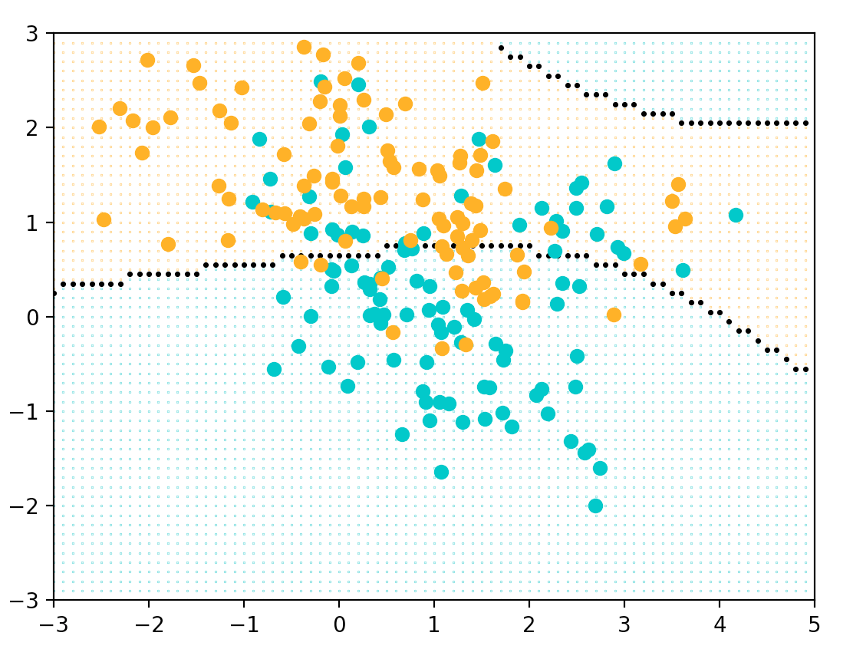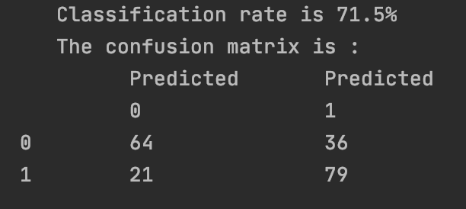

a2cost.py

The confusion matrix and graph are shown as bellow. The correctness rate is 94.68%, 95.75%, and 95.75%.

Since The value in priors are different in graph a and graph b, graph a has larger blue, red and orange area, graph b has larger green area. Due to different cost functions, graph a has larger blue, red and orange area, graph c has larger green area.

|  |  |  |
| --- | --- | --- |
| a | b | c |
|  |  |  |
| |  |  |  |  | | --- | --- | --- | --- | | 20 | 0 | 0 | 3 | | 0 | 28 | 0 | 1 | | 0 | 0 | 27 | 1 | | 0 | 0 | 0 | 1 | | |  |  |  |  | | --- | --- | --- | --- | | 18 | 0 | 0 | 0 | | 0 | 28 | 0 | 1 | | 0 | 0 | 27 | 1 | | 2 | 0 | 0 | 17 | | |  |  |  |  | | --- | --- | --- | --- | | 18 | 0 | 0 | 0 | | 0 | 28 | 0 | 1 | | 0 | 0 | 27 | 1 | | 2 | 0 | 0 | 17 | |
| Correction rate:  94.68% | Correction rate:  95.75% | Correction rate:  95.75% |

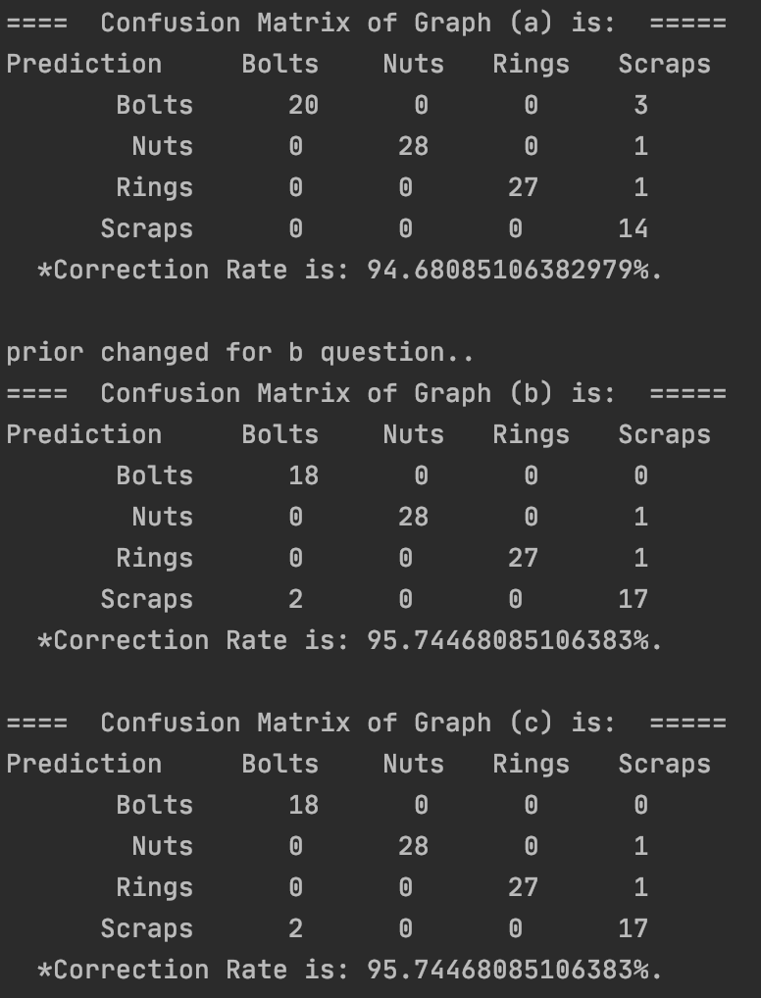

3. When the number of scrap objects is doubled, the revised cost function matrix is shown as following so that decision boundary is not changed:

|  |  |  |  |
| --- | --- | --- | --- |
| -0.40 | 0.14 | 0.14 | 0.07 |
| 0.14 | -0.30 | 0.14 | 0.07 |
| 0.14 | 0.14 | 0.10 | 0.07 |
| 0.06 | 0.06 | 0.06 | 0.03 |

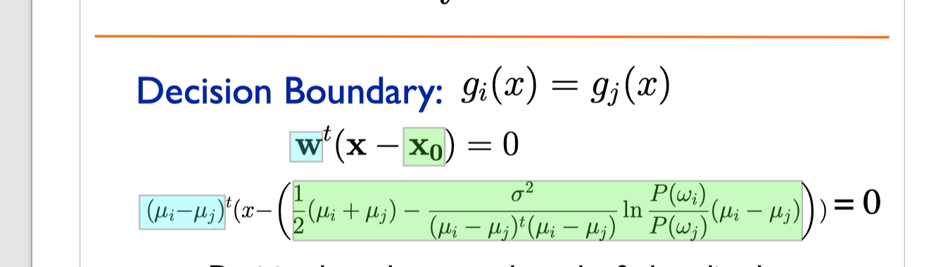

In the decision boundary formula, the only affected variables are P(wi) and P(wj). Therefore, when P(wi) is increasing, P(wj) decreasing. In this way, decision boundary will be changed. To avoid this change, in classification, we should minimize the risk and composite to P(wj). Thus, we double the columns not including(Pwi) in the original cost function matrix.